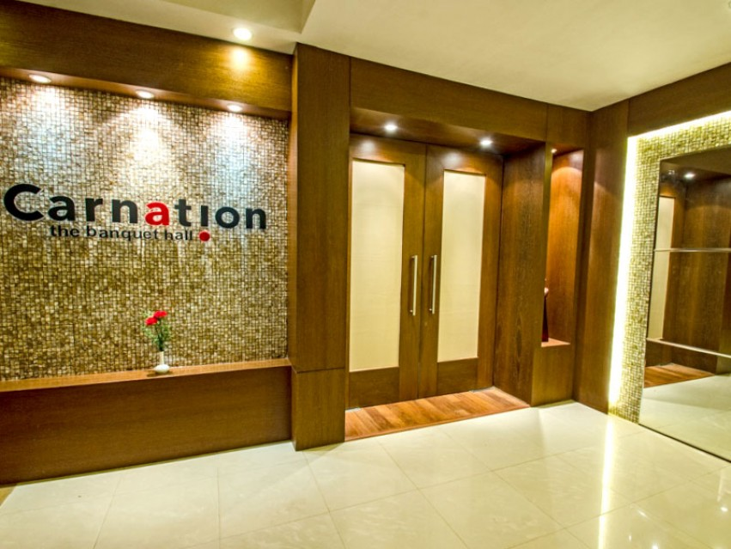
Curry Leaf
Curry leaf is a delightful venue for all who enjoy Indian traditional fare with a twist, outside of ones kitchen, Curry leaf specialises in handpick cuisines from across India. The restaurant can accommodate 60 guests comfortably.
Eat Street
A multicuisine restaurant where food is an addiction, step in and dig your hearts into authentic food, prepared with love by our Master Chefs.
Whether it is for a high-level business meeting, a large Conference or a small seminar, The Hotel Calangute Towers concentrates on the details so that you can focus on the bigger picture.
We offer your meetings a new perspective with a fabulous choice of locations which ensures your event is a success with a fully dedicated business centre, offering all the requirements of today's busy executive, including a personalized secretarial service.
Meeting, Conference and Banqueting facilities are available. Full AV equipment is on hand to sustain any delegate’s requirement.

